

KAMPALA CAPITAL CITY AUTHORITY

VALUATION OBJECTIONS DIGITAL REGISTRY PROCESS

MAY, 2023

DOCUMENT RELEASE NOTE

Notice No.: KCCA/URS/Valuation Objections Digital Registry System/1.0
Name of Client: Kampala Capital City Authority
Project Name:

Document Details
Name | Version no. | Description
Valuation Objections Digital Registry System - 1.0 | Version 1.0

Revision details
Action taken  (add/del/change) | Previous  page no. | New page no. | Revision description
Delete |  | 13-15 | Removed the adjournment process.

Change Register serial numbers covered:
The documents or revised pages are subject to document control. Please keep them up-to-date using the release notices from the distributor of the document.
This is a confidential document.

Process Owner: Valuation court.

Created by (Department of I.C.T);
Name: ………………………………………………………………
Position: ……………………………………………………………
Signature: …………………………………………………………
Date: ………………………………………………………………
Approved by (Process Owner);
Name: ………………………………………………………………
Position: ……………………………………………………………
Signature: …………………………………………………………
Date: ………………………………………………………………

ABOUT THIS MANUAL

Purpose
The purpose of this document is to lay down the broad user requirements for the proposed Valuation Objections Digital Registry System. This has also been developed after analysing the current challenges and the proposed processes aligned to the KCCA Valuation Objections Digital Registry guidelines. This document is for users and the project development team.

Intended Audience
This document will help:
- Kampala Capital City Authority to understand and approve the system requirements of the proposed Valuation Objections Digital Registry system.
- The acceptance testing team to develop test data and to test the system.
- The maintenance team to understand all aspects of the application, and maintain it.

References.
- Requirements gathered from BPR by the requirements team.
- Existing Forms and Formats that are currently being used by the Valuation Court (acquired directly from the Valuation Court and the official website of KCCA).
- BPR proposals suggested and approved by KCCA.

How to Use this Document
All users of this document should carefully read it, and ensure the following:
- All requirements have been listed and detailed correctly.
- Functionality described in this document is clear and unambiguous.

CONTENTS
DOCUMENT RELEASE NOTE III
1.1 Document Details III
1.2 Revision details III
ABOUT THIS MANUAL IV
1.3 Purpose IV
1.4 Intended Audience IV
1.5 References IV
1.6 How to Use this Document IV
CONTENTS V
LIST OF ABBREVIATIONS VII
1. INTRODUCTION 1
1.1 Purpose 1
1.2 Scope 1
1.3 User Categories 1
1.4 Functionality and User Mapping 2
2. REQUIREMENTS 3
2.1 USER MANAGEMENT 3
2.2 SYSTEM CONFIGURATION 3
2.3 VALUATION OBJECTIONS DIGITAL REGISTRY SYSTEM PROCESS 4
Objection process 4
3. Annex 1 19
VALUATION OBJECTIONS DIGITAL REGISTRY SYSTEM JOURNEY 19
4. Annex 2 20
VALUATION OBJECTIONS DIGITAL REGISTRY SYSTEM FORMS 20

LIST OF ABBREVIATIONS

Abbreviation/ Acronym | Description
KCCA | Kampala Capital City Authority
URS | User Requirements Specifications
BPR | Business Process Re-Engineering
MIS | Management Information System
SMS | Short Messaging Service

INTRODUCTION

Purpose
User Requirement Specification (URS) for the Valuation Objections Digital Registry Module has been prepared with a view to provide the following:
- Details of the user requirements that need to be supported by the application software.
- A basis for mutual understanding between the users and software design / customization / development team.
- A basis for subsequent module development and testing.

Scope
This document gives the framework of the following:
- Broad functionalities within the online Valuation Objections Digital Registry module.

User Categories
User Categories for the Valuation Objections Digital Registry module will include;
- Objector.
- Chairperson (Valuation Court).
- Clerk (Valuation Court).
- Registrar (Valuation Court).

Functionality and User Mapping

No. | System Role Name | Functionality(ies) | Objector | Chairperson | Clerk | Registrar
 | Data Entry Authority | - Input objection data
 | Verification Authority | - Review and update any changes if any in the system.
 | Approving Authority | - Approve the captured data

REQUIREMENTS

The Valuation Objections Digital Registry Module includes capturing, the Objectors details, property details and reasons of objection. This is intended to provide for real-time acquisition of an objection case file number.

Functionalities of the Valuation Objections Digital Registry include:
- Data capture.
- Generation of a case file number for each of the different Objectors.
- Schedule of court hearings.
- Notifications on the system, SMS and emails.
- MIS Reports.

USER MANAGEMENT
This module will be developed to enable users to access the Valuation Objections Digital Registry.

SYSTEM CONFIGURATION
This module will be developed to enable users register their objections.

VALUATION OBJECTIONS DIGITAL REGISTRY SYSTEM PROCESSES.

THE OBJECTION SUBMISSION PROCESS.
Name of Process: | Objection Submission process
Process Owner: | Valuation Court
Created By: | BPR TEAM | Last Updated By:
Date Created: | February, 2023 | Last Revision Date:
Process Purpose: | The purpose of the objection submission process is to enable an Objector to submit and file one or more objections, to assign a case file number for every Objector as well as to assign a unique objection number to each objection.
Process Scope: | This process will cover the filling in and submission of objections.
Actors | - Objector.  - Registrar (Valuation Court).
Process Input: | Objection form.
Process Flow: | When the Objector is submitting an Objection.  - The Objector will access the KCCA system and fill the Objection form in a prescribed format through the Valuation Court module. Necessary attachments will be made according to the reason for objection.  - In the event that an Objector has more than one objection, he/she will be able to register more than one objection before saving and submitting.  - Upon submission, the system will generate a case file number in the format (Division code/ Year/ Sequential number_ NAK23XXXXX).  - The objection will then be added to the Objections list which will be generated and pending actions from the valuation court.  - A notification will also be generated and sent to the Objector with his / her assigned case file number in the form of an SMS and email.  - In the event that the Objector wants to add another objection after submission, the system will provide for the addition of another objection. The Objector will access the system and input the case file number to access his / her objection file before adding another objection to the said file.  Note 1: The Valuation Court Registrar will have the rights to submit an objection on the behalf of a given objector.  Note 2: The system will have a note telling the objectors to carry physical copies of the attachments (if any) with them when going for the court hearing.  Note 3: During the 30-day period of submitting objections, only the Registrar of the Valuation Court will have the privilege to access and view the objections which have been submitted into the system.  When the Registrar is closing the period of submitting Objections.  - At the end of the 30-day time-period within which objections are to be submitted by the Objectors, the Registrar will use the system to generate a list of all the objections which will have been submitted. This list is to be approved by the Executive Director before the Valuation Court can begin working on any objections.  - After the list has been approved, the Registrar will give rights to the other members of the Valuation Court such as the Clerk and the Chairperson to move to the next step of scheduling hearing dates for the submitted objections.
Output | - Case file number.  - Objection number.  - List of submitted objections.
Control Points and Measurements: | The verification and approval processes by the Registrar.  - When the valuation court is still in the period of receiving objections, only the registrar will be able to view the objections which will have been submitted into the system at a given point in time.  - When the time period of receiving objections has come to an end, the Registrar will be able to generate and print a list of all the submitted objections for approval by the Executive Director. After this list has been approved, the Registrar will give the Clerk and Chairperson of the Valuation Court rights to access the submitted objections and carryout the necessary actions.
Attachments | - Copy of Sales agreement.  - Copy of Tenancy agreement.  - Copy of Land title.  Note: The attachments are not limited to the above mentioned but they tend to change depending on the nature and reason for objection.

Process Flow Chart for Objection Process
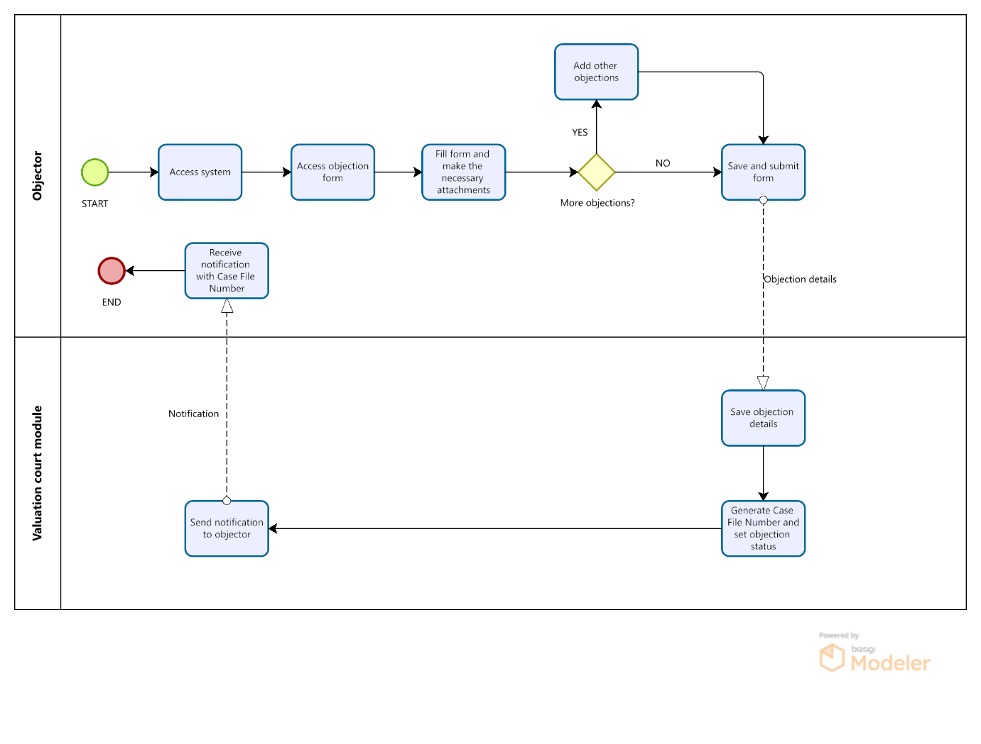

THE WITHDRAW OF OBJECTION PROCESS.
Name of Process: | Withdrawal of Objection Process
Process Purpose: | The purpose of the online Withdraw of Objection Module is to provide for real-time withdrawal of an objection.
Process Scope: | This process will cover filling in of the withdraw of objection form by the Objector and approval of withdrawal by the Chairperson.
Actors | - Objector.  - Chairperson (Valuation Court).  - Registrar (Valuation Court).
Process Input: | - Case File Number.  - Objection Withdrawal Form.
Process Flow | When the Objector is filling the withdraw of objection form.  - The Objector will be required to access the KCCA system before inputting their case file number.  - If the input case file number is correct, the system will display the case objection file together with the list of all lodged objections with their objection numbers from which the Objector will select the specific objection to withdraw.  - After selecting the objection to withdraw, the Objector will access the withdraw objection form. The Objector and property details will be auto-populated into the form whereas the reasons for withdrawal will be input in the prescribed format before submitting.  - After the Objector has submitted the withdraw of objection form into the system, a system notification will be sent to the Valuation Court Chairperson and Registrar about the request to withdraw the Objection.  - After the Chairperson has approved the Objector’s request to withdraw the lodged objection, a notification will be sent to the Objector and the said objection removed from the list of active objections. A system notification will be sent to the Registrar as well.  When the Chairperson of the Valuation Court is approving a withdraw of objection.  - The Chairperson will login to the system using the credentials provided by the system admin.  - The Chairperson will then access the list of pending objection withdrawal requests.  - The Chairperson will then select and review a specific objection withdrawal request. The Chairperson will review the details such as the name of the Objector, the objection which is being withdrawn, the reasons for the withdrawal, etc.  - The Chairperson will Approve the lodged objection withdraw request if he deems fit else will reject with a reason.  - The system will then send a notification to the Objector informing him / her about the approval or rejection of their request to withdraw an objection. A system notification will also be sent to the Registrar.  - If the objection withdrawal request has been approved by the Chairperson, the system will update the status of the said objection from Submitted to Withdrawn before moving it to the list of withdrawn objections.  Note 1: Both the Chairperson and Registrar will be able to view the list of withdrawn objections together with their details such as the date when an objection withdraw request was made as well as when it was approved, the reasons as to why it was withdrawn, the name of the Objector, etc.  Note 2: Both the Chairperson and Registrar will be able to view all the objection withdraw requests as well as identify the ones that have been rejected, approved and those that are still pending action from the Chairperson.
Output | - Withdraw of objection notice.  - Notifications.
Control Points and Measurements: | When the Objector is filling the withdraw of objection form.  - A control point is established in steps 4 and 5 where after the Objector has filled in and submitted the withdraw of objection form, the system will notify the Chairperson of the valuation court and prompt him / her to approve the withdraw of objection. The task of withdrawing an objection cannot be completed when the Chairperson of the valuation court has not approved the process.  - The Registrar will also be able to see the objection withdraw requests which have been submitted as well as whether they have been attended to.

Process Flow Chart for Withdraw of Objection Process
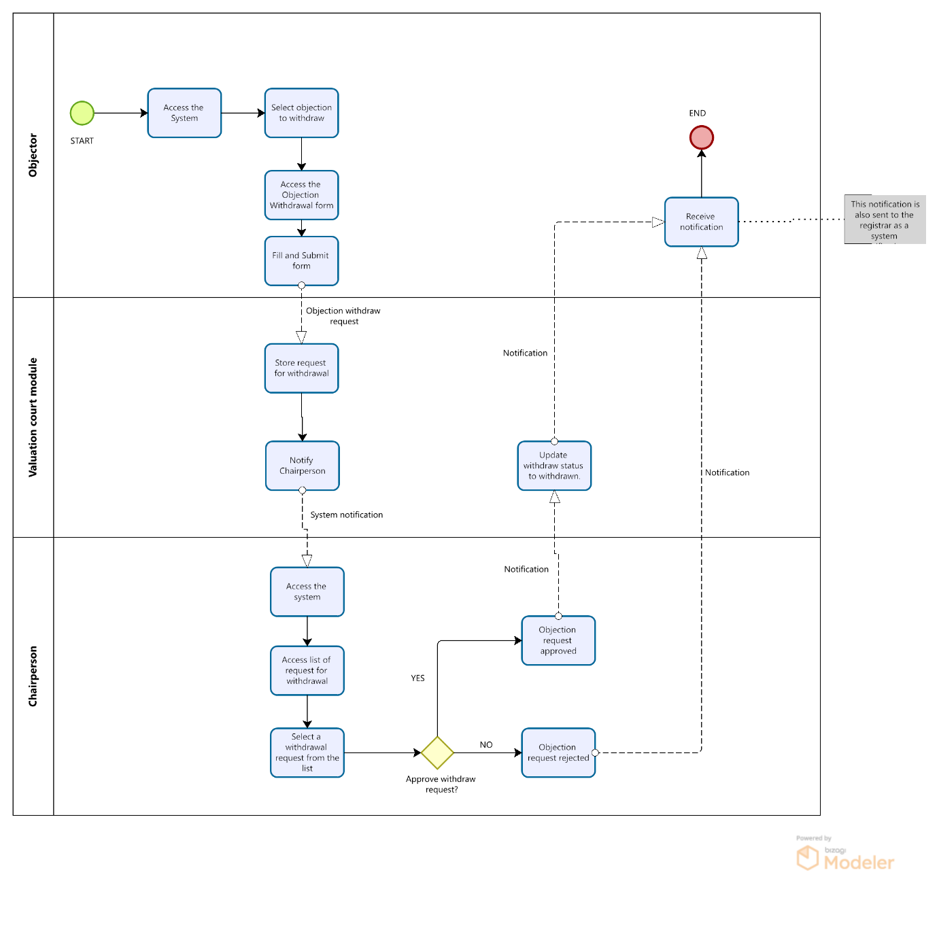

THE SCHEDULING PROCESS.
Name of Process: |  | Scheduling Process
Process Owner:
Created By: |  |  | Last Updated By:
Date Created: |  | February, 2023 | Last Revision Date:
Process Purpose: | The purpose of the Scheduling Process is to enable the Clerk of the Valuation Court to assign a hearing date and time for an Objector to appear before the Valuation Court.
Process Scope: | This process will cover assigning of a hearing date and time, generation of a hearing notice, sending a notification by SMS and email as well as the acknowledgement of receipt of a hearing notice by the Objector.
Process Actors: | - Clerk (Valuation Court).  - Registrar (Valuation Court).  - Objector.  - Valuer.
Process Input: | - The Case File Number.  - Hearing date.  - Hearing start time.  - Venue/Location.
Process Flow: | When the Clerk is scheduling and approving a Court Hearing.  - The Clerk will log onto the system using his credentials and access a list of all the objection files that have been submitted for action.  - The system will then present the submitted objection files in a format which will provide insights that will enable the Clerk to create a convenient hearing schedule. Insights such as organizing / filtering the objection files in terms of the number of objections they contain, the nature of the objection, the date an objection was submitted, etc.  - The Clerk will then select and open an objection file from the list.  - After opening a specific objection file, the Clerk will be able to view additional details concerning it such as the different objections under it, the name and details of the Objector, etc.  - The Clerk will then click on the Schedule Court Hearing button.  - Upon clicking on Schedule Court Hearing, a scheduling form will be displayed. The Clerk will select the date and time and fill it in the prescribed format.  - The system will then generate and display the hearing notice to the Clerk. The generated hearing notice will have the fields of Objection File Number, Objector’s Name, hearing date, time and venue automatically populated depending on what the Clerk filled into the form.  - At this point, the Clerk will view this hearing notice and decide to either cancel or approve it. If the Clerk decides to select the cancel option at this point, the system will discard the generated hearing notice and once again present the scheduling form to the Clerk so as to enable him / her make the necessary adjustments in the scheduling of the said court hearing.  - On the other hand, upon approval of the hearing notice, the system will save the details of the scheduled court hearing and update the status of this case objection file from “Objection Submitted” to “Awaiting Court Hearing”.  - The system will then send a notification in form of an email and SMS to the Objector.  - The Clerk will then be able to go back to the list of submitted objection files and view the Scheduled Court Hearings. Here he/she will view a list of the scheduled court hearings in the order of their allocated dates.  Note 1: The Chairperson, Clerk and Registrar will have access to view the list of scheduled hearing dates and any other related details.  Note 2: The system will only have two timeslots (morning and afternoon) from which the Clerk will have to select in order schedule a given hearing.  When the Objector receives the court hearing email notification and is downloading and acknowledging receipt of the hearing notice  - The Objector will receive an SMS and email notification containing the date, time and venue of the court hearing. The email will contain a link which will prompt the Objector to click in order to view and download the hearing notice with which he / she will be expected to appear in the Valuation court.  - Upon clicking the link in the email notification message, the Objector will be redirected to a page on which he / she will be able to view his / her hearing notice.  - The Objector will then be expected to select a checkbox containing a message agreeing to the fact that he has received and viewed the hearing notice.  - After selecting the checkbox, the Objector will click the “Acknowledge Receipt and Download Hearing Notice” button to download a pdf copy of the approved hearing notice onto his / her device. The system will not allow the Objector to download the hearing notice without selecting the checkbox.  - After the Objector has downloaded the hearing notice, the system will record in the details of the case objection file that the hearing notice was received by the Objector.  - If the Objector won’t make it for the court hearing, he / she will notify the court and send a representative.  Note 1: The Chairperson, Clerk and Registrar will have access to view the list of all the objectors who have acknowledged receipt of the hearing notice as well as those who haven’t.
Process Outputs: | - Hearing Notice.  - Notification of assigned hearing date, time and location.
Exceptions to Normal Process Flow: | None.
Control Points and Measurements: | When the Clerk is scheduling and approving a Court Hearing.  A control point is established in steps 7 to 10 where after the Clerk has filled and submitted the scheduling form, the system will display the generated and automatically populated hearing notice to give him / her an opportunity to verify the information displayed on it to make sure that it is accurate before finally approving and sending it out to the Objector.  When the Objector receives the court hearing email notification and is downloading and acknowledging receipt of the hearing notice.  A control point is established in steps 4 and 5 where the Objector will be expected to select a checkbox agreeing to the fact that he / she has received and viewed the hearing notice before being able to download it.
Attachments | None

Process Flow Chart for Scheduling Process
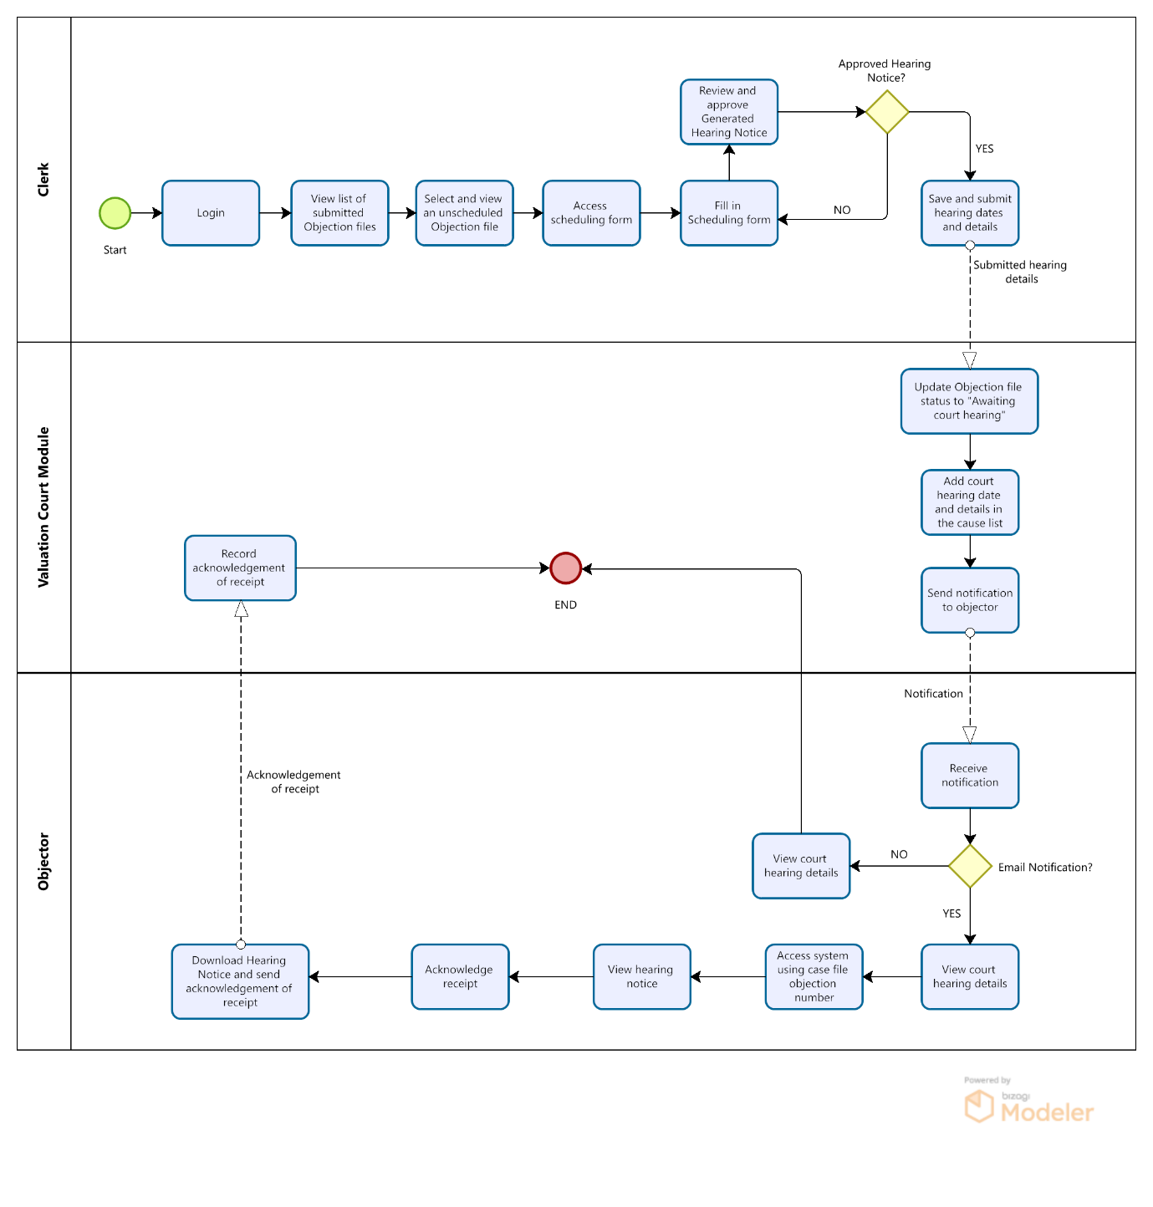

THE OBJECTOR REPRESENTATIVE PROCESS.
Name of Process: | Objector Representative Process
Process Purpose: | The purpose of the Objectors representative process is to enable the Objector notify court in case he / she is unable to make it for the court hearing and send a representative.
Process Scope: | This process will cover filling in of the representative details by the Objector and notifications will be sent to the Registrar and the Clerk.
Actors | - Objector.  - Clerk (Valuation Court).  - Registrar (Valuation Court).
Process Input: | - Case File Number.  - Representatives details.
Process Flow | - In case the Objector won’t make it for the court hearing, he / she will access the system to notify the court by inputting his / her case file number.  - The Objector will then access the representative form and fill it in the prescribed format.  - Upon submission, a system notification will be sent to the Clerk and Registrar notifying them of the failure of the Objector to make it for the court hearing and the details of the representative.  - The Clerk will login to the system using his or her credentials to review the details of the representative and approve the Objector’s request to send a representative.  - If the request to send a representative is approved, an email and SMS notification will be sent to the Objector notifying him / her about the approval of his / her request to send a representative for the court hearing. The Registrar will also receive a system notification concerning whether the Objector`s request to send a representative has been approved or rejected by the Chairperson.  - If the request to send a representative is rejected, the Objector will receive an email and SMS notification with reasons for rejection. The Registrar will also be able to view which request have been rejected and which ones have been approved.  Note: The system should have a note informing the representative to come with a copy of his/her National ID and a signed letter from the objector when appearing in court.
Control Points and Measurements | When the Objector is suggesting a representative to send for the court hearing.  A control point is established in step 4 where after the Objector has filled in and submitted the representative form, the system will notify the Clerk of the valuation court and prompt him / her to approve the representative request. The task of requesting to have a representative cannot be completed when the Clerk of the valuation court has not approved the representative.
Output | Notification.

Process Flow Chart for Objector Representative Process.
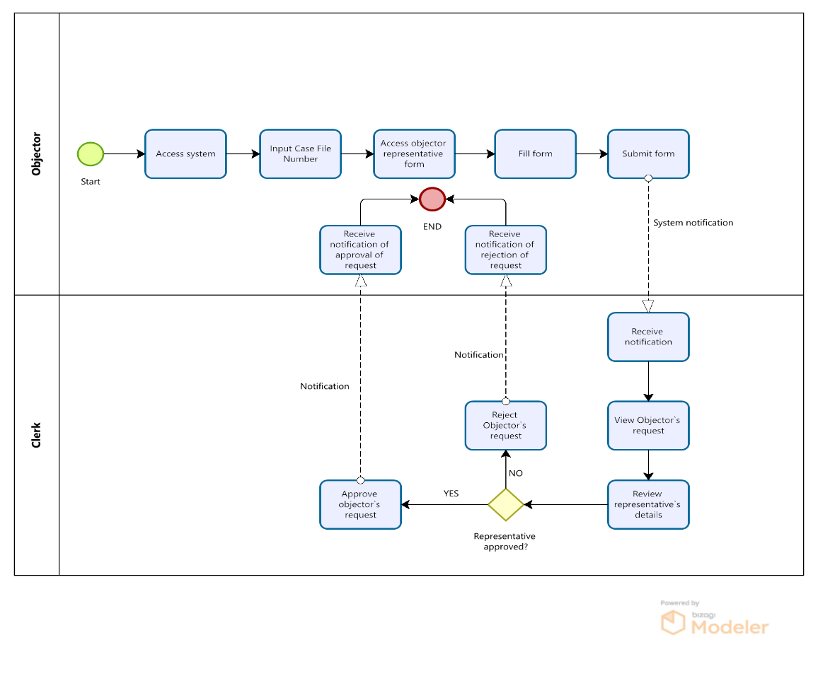

THE COURT PROCEEDING AND RULING PROCESS.
Name of Process: | Court Proceeding and Ruling Process
Process Purpose: | The purpose of the Court Proceeding and Ruling process is to provide fields for inputting data from court proceedings as well as inputting the court ruling into the system after it has been created by the Chairperson.
Process Scope: | This process will cover filing in of the court proceedings and uploading the court ruling.
Actors | - Chairperson (Valuation Court).  - Registrar (Valuation Court).
Process Input: | - Court Proceedings Form.  - Court Ruling Form.
Process Flow | When the Clerk is inputting the proceedings of a court hearing into the system.  - The Clerk will access the system through the web and sign in using his / her credentials.  - The Clerk will access the List of Objection Case Files with the status” Awaiting court hearing”.  - The Clerk will then select and open the Objection Case File which contains the objection whose hearing proceedings he / she wants to upload into the system.  - The system will then display all the objections in the opened Case Objection File together with their objection numbers.  - The Clerk will then select the objection whose court proceedings he / she wants to upload into the system before accessing the court proceedings form.  - The system will then display the form for adding court proceedings which the Clerk will fill in the prescribed format.  - After the court proceedings for a given objection have been uploaded by the Clerk, the status of that objection will be updated to “Awaiting Court Ruling”.  When the Chairperson/Clerk is uploading the court ruling of a court hearing of an objection onto the system.  - After the court hearing, the Chairperson/Clerk will take time to manually develop the court ruling, type and convert it into the pdf format.  - The Chairperson/Clerk will then log into the system using his / her credentials and then select a Case Objection File from the list of files with the status, “Awaiting Court Ruling”.  - In case the selected Case Objection File has more than one objection, the system will display a list of all lodged objections with their objection numbers from which the Chairperson/Clerk will select the specific objection to which he / she intends to add a court ruling.  - After opening the objection, the Chairperson/Clerk will be able to view additional details concerning it such as the date and time the hearing was held as well as the court proceedings which were submitted.  - The Chairperson/Clerk will then click on the add court ruling button.  - The system will then present a form which the Chairperson/Clerk will use to upload the pdf copy of the court ruling and input the necessary remarks before saving and submitting into the system.  - The system will then change the status of this objection from “Awaiting Court ruling” to “Objection closed”.  - The saved ruling will then be in the Objectors list with status Objection Closed. The system will allow for original print after the first print the rest will appear as Duplicate prints.  Note 1: After the Chairperson has uploaded the court ruling, no notification will be sent by the system to the Objector. The Objector will instead be manually informed by use of phone call and/or SMS.  Note 2: The Registrar will be able to access, view and track the progress of all the objections in the system.
Output | - Court Ruling.  - List of Completed Objections.

Process Flow Chart for Court Proceedings and Ruling Process.

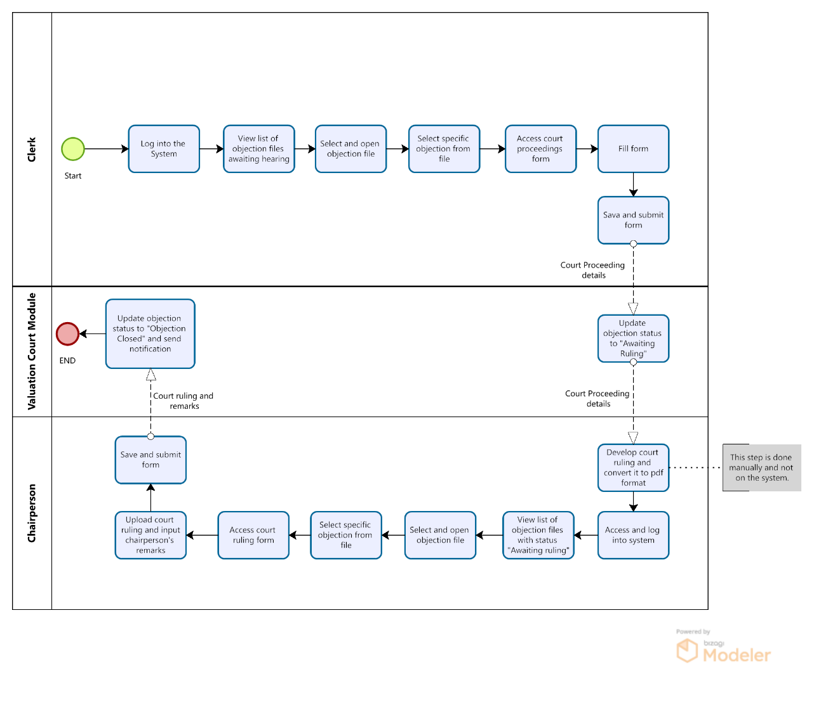

Annex 1

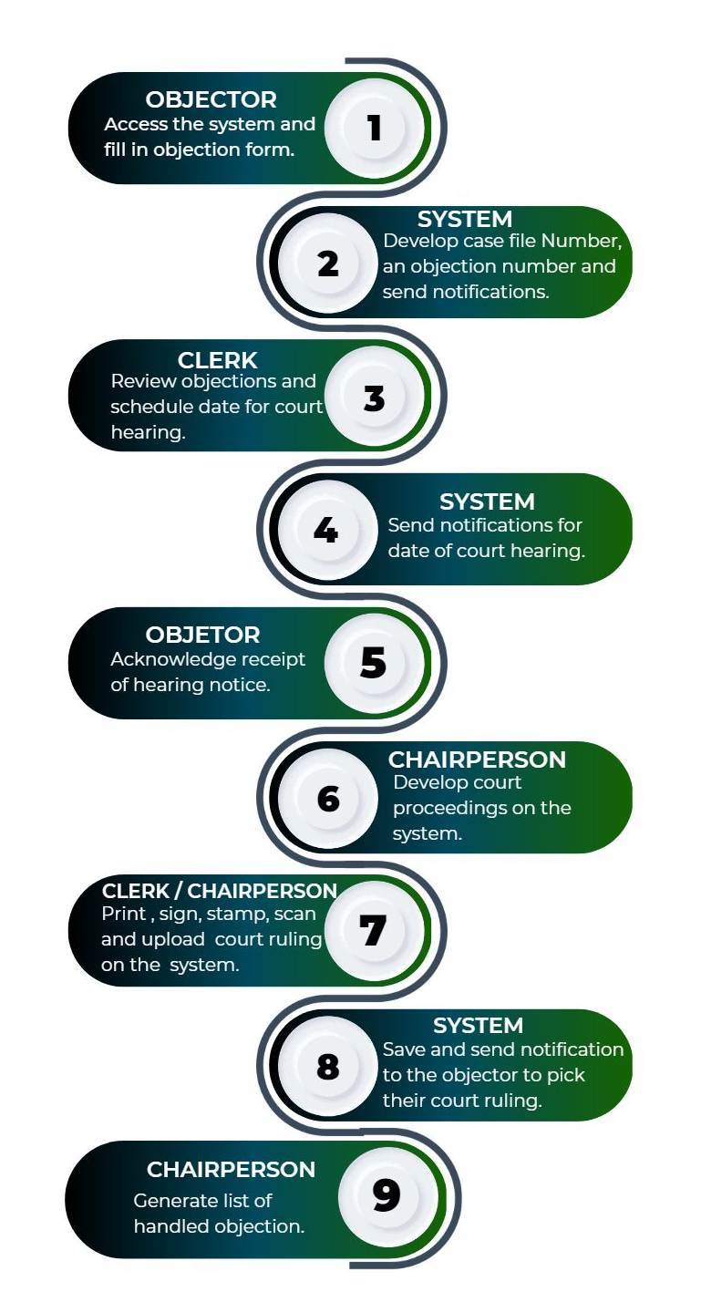
VALUATION OBJECTIONS DIGITAL REGISTRY SYSTEM JOURNEY

Annex 2

VALUATION OBJECTIONS DIGITAL REGISTRY SYSTEM FORMS

Objection Submission Process form and attachments
Defintion of Field status
M – Mandatory
O – Optional
C – Conditional
Mp – Multiple
AP-Auto populate

Sr. No. | Field Name | Field Status | Reference For conditional field | Remarks
Section A: Property Details.
 | Property Reference No. | M
 | Division | M
 | Parish | M
 | Zone | M
 | Block | M
 | Plot | M
Section B: Objector Details.
 | COIN | O |  | Text input.
 | First Name | M |  | Text input.
 | Middle Name | O |  | Text input.
 | Last Name | M |  | Text input.
 | Telephone Number (s) | M |  | Text input.
 | Email Address | O |  | Text input.
 | Physical Address | M |  | Text input.
Section D: Objections Details.

 | I/We the owner (s)/occupier (s)/other | M |  | Tick the appropriate radio button.  - Owner (s)  - Occupier (s)  - Other
 | Other objector details | C | I/We the owner (s)/occupier (s)/other. | The Objector will only have to fill this field if he / she has selected the option, “Other”, on the field number 14.
 | Of the rateable property(ies) specified below | M |  | Physical address of the rateable property
 | Object against;  - The inclusion of any rateable property  - The value of a rateable property  - Any other statement made or omitted to be made about any rateable property  - The decision to split or combine the listing of any rateable property(ies) | M |  | Tick the applicable box (can select more than one)
 | Details of objection and amendments required | M |  | Open text field.
 | Upload any other attachments | O |  | Attachments can either be images or pdf documents

Withdraw of Objection Form.
SN. | Field Name | Field Status |  | Reference For conditional field |  | Remarks
 | Objection Number |  | AP |  |  |  | Cannot be edited.
 | Objector’s Name |  | AP |  |  |  | Cannot be edited (Auto populated depending on the name provided by the Objector when submitting objection).
 | Objection withdrawal reason |  | M |  |  |  | Open text field (Give details).

Scheduling Form.
SN. |  | Field Name | Field Status | Reference For conditional field | Remarks
Section A
 | Case File Number |  | AP |  | Cannot be edited.
 | Name of Objector |  | AP |  | Cannot be edited.
 | Name of Valuer |  | M
Section B; Date, Time and Location of Court Hearing
 | Hearing Date |  | M |  | Selected using a calendar (date picker).
 | Hearing Start Time |  | M |  | Selected using a clock (time picker).
 | Hearing Venue |  | M |  | Text input.

Objector Representative Form.
SN. |  | Field Name | Field Status | Reference For conditional field | Remarks
Section A: Objector details.
 | Objector`s Name |  | AP |  | Cannot be edited.
 | Case File Number |  | AP |  | Cannot be edited.
 | Scheduled Date |  | AP |  | Cannot be edited.
 | Scheduled Time |  | AP |  | Cannot be edited.
 | Hearing Venue |  | AP |  | Cannot be edited.
Section B: Representative details.
 | First Name |  | M |  | Text input.
 | Middle Name |  | O |  | Text input.
 | Last Name |  | M |  | Text input.
 | NIN / Passport Number |  | M |  | Text input.
 | Phone number |  | M |  | Text input.
 | Email |  | O |  | Text input.
 | Physical address |  | M |  | Text input.
 | Relationship |  | M |  | Text input.
 | Designation |  | M |  | Text input.
 | Representation reasons |  | M |  | Open text field.

Court Proceeding Form.
SN. | Field Name | Field Status | Reference For conditional field | Remarks
 | Objection Number | AP
 | Reference Number | AP
 | Objector’s Name | AP
 | Introductory Details | M
 | Objector’s Submissions | M
 | KCCA Valuer’s Submissions | M
 | Rejoinder / Objectors Final Submissions | M
 | Chairman’s Preliminary Decision | M

Court Ruling Form.
SN. | Field Name | Field Status | Reference For conditional field | Remarks
 | Objection Number | AP |  | Cannot be edited (Auto populated depending on the property reference number provided by the Objector when submitting objection).
 | Reference Number | AP |  | Cannot be edited (Auto populated depending on the property reference number provided by the Objector when submitting objection).
 | Objector’s Name | AP |  | Cannot be edited (Auto populated depending on the name provided by the Objector when submitting objection).
 | Court Ruling | M |  | Upload a pdf document
 | Chairperson’s remarks | M |  | Open text field.

List of Objections format.
Below is the format of the list of objections which is to be generated by the system after the period given to the Objectors to submit their objections has come to an end. This list has to be presented to the Executive Director of KCCA for his / her approval before the Clerk of the Valuation Court can begin scheduling hearings for the submitted objections.
S/N | Date of Objection | Objector’s Name | Objector’s Contact | CAMV ID | Nature of Objection | Objection Details | Property Owner Name | Property Owner Contact | Property Type | Property Subtype | Parish | Street | Plot No. | Gross Value | Rateable Value

